Student Name: __________________
Class and Section __________________
Total Points (10 pts) __________________
Due: September 9, 2009 before the class

Project: The MyInteger Class

CSCI 1302 Advanced Programming Principles
Armstrong Atlantic State University

Problem Description:
Design a class named MyInteger. The class contains:
- An int data field named value that stores the int value represented by this object.
- A constructor that creates a MyInteger object for the specified int value.
- A get method that returns the int value.
- Methods isEven(), isOdd(), and isPrime() that return true if the value is even, odd, or prime, respectively.
- Static methods isEven(int), isOdd(int), and isPrime(int) that return true if the specified value is even, odd, or prime, respectively.
- Static methods isEven(MyInteger), isOdd(MyInteger), and isPrime(MyInteger) that return true if the specified value is even, odd, or prime, respectively.
- Methods equals(int) and equals(MyInteger) that return true if the value in the object is equal to the specified value.
- A static method parseInt(char[]) that converts an array of numeric characters to an int value.
- A static method parseInt(String) that converts a string into an int value.

Draw the UML diagram for the class. Implement the class. Write a client program that tests all methods in the class.

Design:
Draw the UML class diagram here

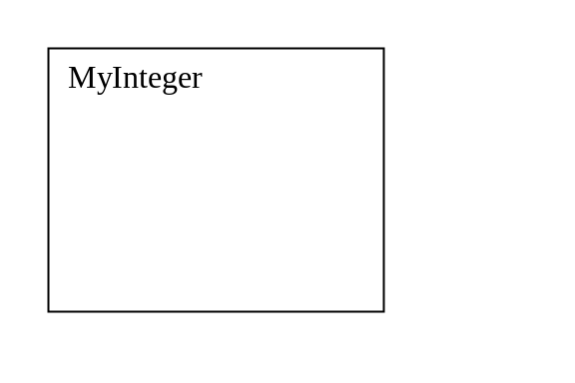

Coding: (Copy and Paste Source Code here. Format your code using Courier 10pts)

public class Exercise10_03 {
public static void main(String[] args) {
MyInteger n1 = new MyInteger(5);
System.out.println("n1 is even? " + n1.isEven());
System.out.println("n1 is prime? " + n1.isPrime());
System.out.println("15 is prime? " + MyInteger.isPrime(15));

char[] chars = {'3', '5', '3', '9'};
System.out.println(MyInteger.parseInt(chars));

String s = "3539";
System.out.println(MyInteger.parseInt(s));

MyInteger n2 = new MyInteger(24);
System.out.println("n2 is odd? " + n2.isOdd());
System.out.println("45 is odd? " + MyInteger.isOdd(45));
System.out.println("n1 is equal to n2? " + n1.equals(n2));
System.out.println("n1 is equal to 5? " + n1.equals(5));
}
}

class MyInteger {
// Implement your class here
}

Submit the following items:

1. Print this Word file and Submit to me before the class on the due day.

2. Compile, Run, and Submit to LiveLab (you must submit the program regardless whether it complete or incomplete, correct or incorrect)

Solution Code:

public class Test {
public static void main(String[] args) {
MyInteger n1 = new MyInteger(5);
System.out.println("n1 is even? " + n1.isEven());
System.out.println("n1 is prime? " + n1.isPrime());
System.out.println("15 is prime? " + MyInteger.isPrime(15));

char[] chars = {'3', '5', '3', '9'};
System.out.println(MyInteger.parseInt(chars));

String s = "3539";
System.out.println(MyInteger.parseInt(s));

MyInteger n2 = new MyInteger(24);
System.out.println("n2 is odd? " + n2.isOdd());
System.out.println("45 is odd? " + MyInteger.isOdd(45));
System.out.println("n1 is equal to n2? " + n1.equals(n2));
System.out.println("n1 is equal to 5? " + n1.equals(5));
}
}

class MyInteger {
private int value;

public int getValue() {
return value;
}

public MyInteger(int value) {
this.value = value;
}

public boolean isPrime() {
return isPrime(value);
}

public static boolean isPrime(int num) {
if ((num == 1) || (num == 2)) {
return true;
}

for (int i = 2; i <= num / 2; i++) {
if (num % i == 0) {
return false;
}
}

return true;
}

public static boolean isPrime(MyInteger o) {
return isPrime(o.getValue());
}

public boolean isEven() {
return isEven(value);
}

public boolean isOdd() {
return isOdd(value);
}

public static boolean isEven(int n) {
return n % 2 == 0;
}

public static boolean isOdd(int n) {
return n % 2 != 0;
}

public static boolean isEven(MyInteger n) {
return isEven(n.getValue());
}

public boolean equals(int anotherNum) {
return value == anotherNum;
}

public boolean equals(MyInteger o) {
return value == o.getValue();
}

public static int parseInt(char[] numbers) {
// numbers consists of digit characters.
// For example, if numbers is {'1', '2', '5'}, the return value
// should be 125. Please note that
// numbers[0] is '1'
// numbers[1] is '2'
// numbers[2] is '5'

int result = 0;
for (int i = 0; i < numbers.length; i++) {
result = result * 10 + (numbers[i] - '0');
}

return result;
}

// You may mention this when you covered Ch8
public static int parseInt(String s) {
// s consists of digit characters.
// For example, if s is "125", the return value
// should be 125.
int result = 0;
for (int i = 0; i < s.length(); i++) {
result = result * 10 + (s.charAt(i) - '0');
}

return result;
}
}

